**ID**



ID categorical data

**Age**







  

**Price**



If we are interested banks and corporations treat it as continuous.

So, the level of measurement here is ratio

**Gender**

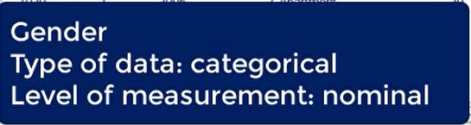



It is very similar to yes or no questions.

Such variables are called binary as there are only two possibilities which are always categorical.

**Location /State**



In fact, we can level the US states from 1 to 50 and use numbers instead.

The variable is categorical and its level of measurement is nominal.



However I prefer the pareto diagram as it gives us additional information

